Table of Contents

# **Basic Information**

**Name:** Vedant Jatin Jolly

**University:** Sardar Patel Institute of Technology, Mumbai University

**GitHub:** [@BassCoder2808](https://github.com/BassCoder2808)

**Gitter Id:** [@basscoder2808](mailto:@basscoder2808-5ef99115d73408ce4fe829ed:gitter.im)

**Email:** [vedantjolly2001@gmail.com](mailto:vedantjolly2001@gmail.com)

**Phone:** (+91) 9004012177

**Postal Address:** Flat no 402, Rail Mitra, Plot no 125, Sector 1, Charkop, Kandivali (W), Mumbai, 400067, Maharashtra, India

**Timezone:** Indian Standard Time (UTC +5.30)

# **Project SPDX License Submission Online Tool - increase functionality**

## **Abstract**

The SPDX-legal team currently relies heavily on the "submit new license" online tool, which is accessed at `https://tools.spdx.org/app/`. This tool creates a new issue in the SPDX License List GitHub repository whenever someone uses it to submit a new license. While the online tool has good capabilities for creating the XML file necessary for licenses that have been accepted to the SPDX License List and submitting a pull request (PR) to the GitHub repository, there are several areas that could be improved upon. The aim of this project is to enhance the online tool's functionality and increase the efficiency of license submissions while easing the workload of the SPDX-legal team.

## **Background**

The SPDX Online Tools is a project that provides an online toolset for creating SPDX (Software Package Data Exchange) documents. SPDX is a standard format for communicating the components, licenses, and copyrights associated with a software package. It was developed by the Linux Foundation's SPDX workgroup to improve the efficiency and accuracy of software license compliance. The toolset includes features for creating new SPDX licenses, creating SPDX files for software packages, and validating SPDX files. The SPDX Online Tools project is particularly important for organizations that use open-source software, as it provides a streamlined way of creating and sharing SPDX files. This is important for facilitating compliance with open-source licenses, which can be complex and difficult to manage. Overall, the SPDX Online Tools project is an important tool for anyone involved in software licensing and compliance, providing an efficient and user-friendly way of creating and managing SPDX files.

## **Motivation**

I am passionate about open-source software and the importance of compliance with open-source licenses. The SPDX Online Tools project, which includes a wide range of tooling and use cases, provides an opportunity for me to gain hands-on experience in this area. While the license submission tool may be more focused on internal or process-oriented use cases for the project, I am eager to explore and contribute to the various other tools and initiatives within the SPDX Online Tools project. Additionally, the project has a strong community of contributors and is actively maintained, which means that I will have the opportunity to work with experienced developers and learn from their expertise. The impact of the SPDX Online Tools project can be seen in the increased efficiency and accuracy in managing software licenses, as well as in the improved communication and collaboration among organizations involved in open-source software development. Moreover, the project's focus on collaboration and improving the efficiency of license submissions resonates with me, as I believe that technology can be a powerful tool for making complex tasks simpler and more accessible. Finally, the project has a clear set of goals and objectives, which will provide me with a structured framework for my GSoC project and enable me to make a meaningful contribution to an important open-source project. Overall, I am excited about the opportunity to work on the SPDX License Online Tool project as part of the GSoC program and to contribute to the development of a toolset that can benefit the open-source community.

## **Project Advantages & its Impact**

The primary objective of this project is to improve the functionality of the existing online tool, thereby increasing the efficiency of license submissions. By doing so, we intend to reduce the workload of the SPDX-legal team and ensure that the entire process is streamlined and hassle-free. Our ultimate goal is to create a user-friendly platform that simplifies license submission, saves time, and enhances overall productivity.

* **Improving Management Efficiency**

Adding the proposed functionality will greatly increase the efficiency of license submissions, as it reduces the manual effort required to create and submit new licenses to the SPDX License List repository. The automatic creation of PRs and files such as the .txt test file can save significant time for the SPDX-legal team and contributors.

* **Improved Error Handling**

By improving error handling, the online tool will be better equipped to handle exceptions and failures that occur during license submissions. This can reduce the time and effort required to troubleshoot and fix errors and can lead to smoother and more efficient workflows.

* **Better Testing**

The addition of unit tests and GitHub API interaction tests with mock can improve the quality of the codebase and reduce the likelihood of errors or bugs. This can lead to a more robust and reliable online tool, which can benefit the SPDX-legal team and contributors in the long run.

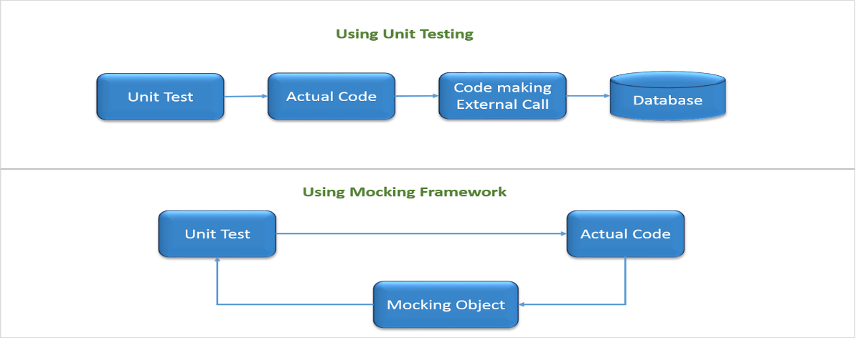

* **Reusable Base App and Better UI**

Creating a base reusable Django app can streamline development efforts and reduce the time and effort required to develop new features or functionality. This can lead to a more efficient and productive development workflow, which can benefit the SPDX legal team and contributors in the long run. Making a better and more efficient UI will help the application be more user friendly and will make the app more accessible.

Through careful planning and implementation of advanced features, we hope to achieve optimal results and establish the online tool as the go-to resource for license submissions in the industry. These improvements will not only make the tool more user-friendly but also ensure it can evolve over time.

# **Why Do I Want to Work on SPDX Online Tools?**

## **Why SPDX License Submission Online Tool - increase functionality?**

SPDX Online Tools is a vital project that helps manage software licenses for various organizations. As the usage of open-source software is increasing, the management of these licenses is becoming a critical task. The SPDX Online Tool project specifically interests me because it has the potential to streamline the license submission process and alleviate the workload of the SPDX-legal team. Working on SPDX Online Tools provides an opportunity to contribute to this important cause and make a difference. The SPDX Online Tool project is an excellent choice for me to work on during GSoC because of its potential impact on the open-source community. This project aims to enhance the functionality of the online tool and increase the efficiency of license submissions while reducing the workload of the SPDX-legal team. As a software engineering student, I have a strong interest in developing scalable software and working with various technologies and libraries. Working on this project will provide me with an opportunity to develop a deeper understanding of web development and APIs, as well as to work with the SPDX License List and GitHub repositories. Finally, SPDX Online Tools is an active project with an engaged community, which provides an opportunity to collaborate with other developers and learn from their experiences. This can be a great learning experience and can help in building a professional network. This project's success will depend on developing new features, improving error handling, adding tests, and automating the submission process, all of which are challenging and exciting tasks. Furthermore, the opportunity to work with an experienced team of mentors and contributors on an open-source project is an invaluable learning experience that I'm eager to have.

## **Why SPDX?**

Choosing SPDX as the organization to work with during summers was a choice motivated by multiple but two major factors. Firstly, SPDX is an open-source organization that is dedicated to creating a standard format for communicating the components, licenses, and copyrights of software packages. SPDX's mission to create a standard format for communicating the components, licenses, and copyrights associated with a software package resonates with me. This is an area that I am passionate about, and I believe that my skills in software development and project management will enable me to make a meaningful contribution to the organization. At the same time it's important to consider the long-term maintenance and sustainability of any project or creation, and this requires a combination of technical skills and strategic planning which I think I have in my locker which will help me make this project successful. In order to ensure that others can build on what I've created and avoid creating single points of failure, I always try to implement certain development practices, such as modular design, clean and readable code, comprehensive documentation, and thorough testing throughout any project that I have worked or contributed to. Secondly, SPDX has a strong community of developers, contributors, and users who are committed to advancing the project and driving innovation in the field of software licensing. Finally, working with SPDX during the GSoC will provide me with an excellent opportunity to gain real-world experience in open-source development, collaborate with other developers, and build my portfolio. I believe that this experience will be invaluable in my career as a software developer and will help me to achieve my long-term goals. Overall, I am excited about the opportunity to work with SPDX and contribute to their mission, and I look forward to a productive and rewarding summer. I am excited to contribute to SPDX and be part of a community that values collaboration, innovation, and making a positive impact in the open-source world.

# **Proposed Deliverables (during GSoC)**

1. **Generate the .txt test file in the pull request (PR) along with the XML file**: This feature will enhance the current capability of the tool to create the XML file by also creating a .txt test file in the PR, thus making the submission process more efficient.
2. **Differentiate exceptions from license submissions**: The tool will be able to differentiate between exceptions and license submissions, which will improve the overall efficiency of the process.
3. **Add or fix unit tests & Improve error handling**: This feature will ensure that the tool is functioning properly, and any errors are caught early in the process. Error handling will be improved, especially when GitHub pull requests fail, which will reduce manual intervention and increase the tool's efficiency.
   * 1. **Write GitHub tests with mocks**
     2. **Separate tests in multiple files**
     3. **Adding tests for edge**
     4. **Tests for UI on browser e.g.: Chrome**
4. **Base Reusable App:** Create a base reusable Django app which contains the core functionality of interacting with java tools and XML along with webapp and API built on top of this base app. This will enable the creation of scalable software and will be a significant learning opportunity.
5. **Add linters to the project - python/js/html/css linters**: This will ensure that the code adheres to the coding standards and best practices, leading to better code quality.
6. **General UI Improvements:** This will help the application be more user friendly and will make the app more accessible. Issues which I have planned to cover in this:
7. **Redirect on Successful License Submission**
8. **Improving the Toast Messages**
9. **Improving the License Text Display on GitHub Issue Section**
10. **Detailed documentation; for users as well as developers.**
11. **Fortnightly blogs on developmental advances and milestones**

# **Detailed Working and Implementation**

## **Generate the .txt file in the PR along with the XML File**

To implement this feature, we would need to make changes to the current codebase of the SPDX online tool. When a user submits a new license request through the tool, the tool generates an XML file and submits a PR to the SPDX License List GitHub repository. To generate a .txt test file in addition to the XML file, we would need to modify the existing code to extract the necessary information from the user's input and create a text file with the required details.

To achieve this, we would need to modify the following files:

* `**views.py**`: This file is responsible for handling the submission of new license requests through the tool. We would need to modify this file to generate a .txt file in addition to the XML file when a user submits a new license request.
* `**generateXml.py**`: This file is responsible for generating the XML file for each license request. We would need to modify this file to extract the necessary information from the user's input and use it to generate the .txt test file.

The first step would be to modify the current online tool's code to create a .txt file with the same name as the XML file when a new license is submitted. We can add this code in the existing function responsible for creating the XML file.

To create the .txt test file, we would need to extract relevant information from the user's input, such as the license name, version, and text which we can easily get from our database model `**License**` for which the code already exists. We would then use this information to create a .txt file in a specific format, such as SPDX's recommended format for test files.

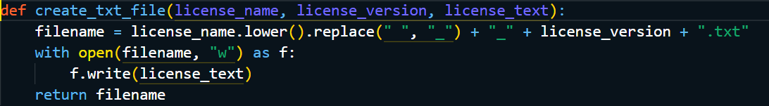

This function takes in the license name, version, and text as input, and generates a .txt file with the appropriate filename and contents. We would need to integrate this function into the existing code to generate the .txt file alongside the XML file.

One problem which can occur above is the formatting of the text which we will be receiving as the input. As mentioned in these two issues [New license request: TEST2-Apache-2.0 [SPDX-Online-Tools]](https://github.com/spdx/license-list-XML/issues/1905) and [New license request: TEST1-Apache-2.0 [SPDX-Online-Tools]](https://github.com/spdx/license-list-XML/issues/1897) formatting from the `**Text**` License field is one of the most difficult parts as when we copy the text from an HTML file it is not getting properly formatted even in the xml file.

The problem is with the `**TextField**` attribute which we have used in our models, as it cannot capture the underlying structure of the data, instead we can make use `**RichTextField**` from `**django-ckeditor**`. RichTextField is designed to be used with a rich text editor, such as CKEditor, which provides a WYSIWYG (What You See Is What You Get) interface for editing and formatting the text. The `**RichTextField**` stores the formatted text in HTML format. This will not only help us while creating the .txt file but also will be easier for our xml file.

Some of the features which RichTextField provides which I think would be a great addition to SPDX-Tools are:

* Configurable editor options: The editor options can be configured to limit the formatting and styling options available to the user, and to control how the content is displayed.
* Customizable templates: Custom templates can be used to control the appearance of the editor and the content it produces.
* Image and file uploads: The editor provides a convenient way to upload and insert images and files into the text.
* Integration with Django's security features: RichTextField is designed to work seamlessly with Django's security features, such as cross-site scripting (XSS) protection.

An example integration into the `License` model will be like:

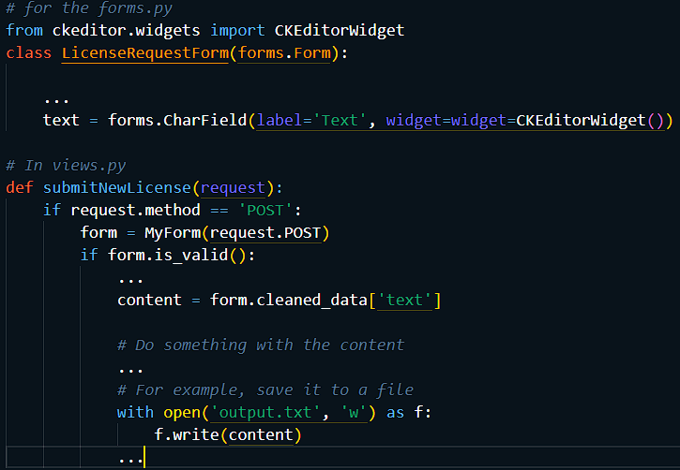

In this example, when the form is submitted, we retrieve the content from the form using the `**cleaned_data**` attribute of the form object and save it to a file called `**output.txt**`. The content will include all the formatting and attributes that were applied in the editor, including bullets and other formatting.

Next step would be to modify the existing code to add the .txt file to the pull request along with the XML file. We can use the PyGithub library to create the pull request and add both files to it. Below is an example code to create a pull request and add files to it.

The implementation below would also be helpful in automatically create a PR with the XML and .txt file when the license submission issue is labeled as **"accepted"** in the GitHub repo thereby removing the manual step of initial creation of the files.

We can also do the same with GitHub workflows, like it will get triggered once the issue labels gets changed to “**accepted**”. One issue which we will need to take care of in that is how would we generate the relevant .txt and .xml files, because we will need to run some backend functions which would write the data in those files.

The final step would be adding unit tests for appropriate error handling and testing to ensure that both files are created and added to the pull request successfully.

Overall, implementing this feature would involve modifying the existing codebase, extracting relevant information from user input, and generating a .txt file in addition to the XML file for each new license request. This would enhance the current capability of the SPDX online tool and make the submission process more efficient.

## **Differentiate Exceptions from License Submission**

To implement this feature, we will need to add a checkbox in the submission form to indicate whether the submission is for a license or an exception. This will allow the tool to differentiate between a license and an exception and use the appropriate tag when creating the XML file and the pull request.

To achieve this, we will first modify the submission form to include the checkbox, which will then be included in the POST request sent to the server. We will then modify the server code to process the checkbox and use the appropriate tag when creating the XML file.

In the `**spdx_online_tools/views.py**` file, we will modify the post() function of the `**SubmissionFormView**` class to handle the checkbox value. We will add a new field to the LicenseRequestForm called "is_exception" and set its value to the checkbox value.

We will then modify the generateLicenseXml () function in the `**spdx_online_tools/generateXml.py**` file to use the appropriate tag based on the checkbox value.

Once the XML file is created, we will need to modify the code that creates the pull request to use the appropriate folder based on the checkbox value.

This will be done in the in the `**create_pull_request()**` function.

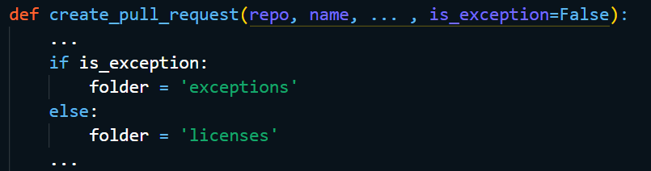

Also, we needed to ensure that in the current system, if the *user changes License --> exception in that tag, and then* ***"beautify"*** *it strips out the other attributions for the license/exception tag as per the* [*Issue*](https://github.com/spdx/spdx-online-tools/issues/398). So, for that, we will need to ensure that the other attributions for the license/exception tag are not stripped out when the XML is beautified. This can be done by adding the `**pretty_print=True**` argument when calling the `**etree.tostring()**` function in the `**spdx_online_tools/generateXml.py**` file.



Another method to solve the above problem, which is simpler, is to add `**exception**` tag in `**TAGS_inline**` in ` **spdx_online_tools/formatXml.py`**. This will take care of the fact that we are handling them when we run the `**pretty**` function there.

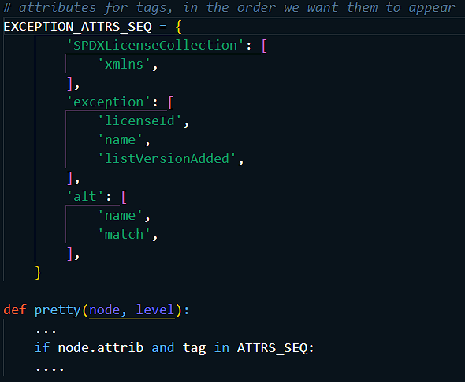

Above, we have created a new attribute sequence, that’s because we don’t want to mix both our license and exception fields as they are independent of each other, we could have also defined the same in the existing `**ATTRS_SEQ**`, but defining them separately would increase the code readability and also not confuse the developer, as to whether or not license and exception can coexist together.

Another issue which needs to be solved is that recently an issue template was also added for submitting licenses directly in GitHub itself, which essentially bypasses use of the SPDX Online Tool. The downside of this is that the license is not captured in the SPDX Online Tool and therefore the auto-XML file generation cannot be leveraged. So, to solve this issue we can make use of webhooks.

We can set up a webhook that listens for new issues created using the GitHub template and automatically submits the license to the SPDX Online Tool. The tool can then generate the XML file and send it back to repository.

We can use a service like Zapier or IFTTT to create a webhook that triggers when a new issue is created in the repository. Once the webhook is triggered, we can make use of the SPDX Online Tool API to submit the license and generate the XML file. After that we can then use another webhook to post the XML file back to your repository.

Steps Involved if we make use of Zappier:

1. Create a new Zap in Zapier.
2. Choose "GitHub" as the trigger app and select "New Issue" as the trigger event.
3. Connect GitHub account to Zapier.
4. Customize the trigger settings to match your specific repository and issue requirements.
5. Choose "Webhooks by Zapier" as the action app and select "POST" as the action event.
6. Enter the URL for the SPDX Online Tool API in the "URL" field.
7. Choose "JSON" as the "Payload Type".
8. In the "Data" section, enter the license information that you want to submit to the SPDX Online Tool API. This will vary depending on the specific license you want to submit and the requirements of the API.
9. Test the webhook to make sure it is working properly.
10. Save the webhook and activate it.

Example JSON Payload for Zappier

## **Add or fix unit tests & Improve error handling**

1. **Write GitHub tests with mocks:**

To write tests for GitHub API interaction with mock, we will be using the `**requests-mock**` package. This package allows us to mock requests to any external APIs, including GitHub APIs.

To start, we will create a new Python file named `**test_github.py**` in the tests directory. In this file, we will import the necessary modules and create a test class for the GitHub API tests. We will then create methods for each test case that we want to run.

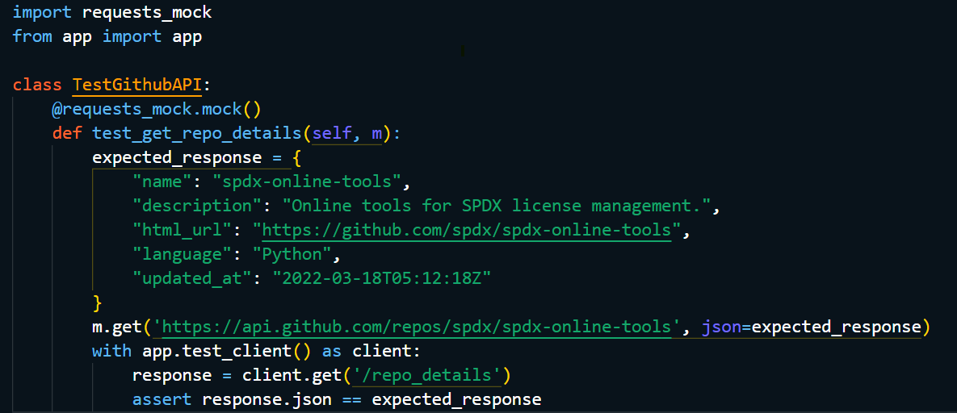

In this test case, we use the `**@requests_mock.mock()**` decorator to mock the GET request to the GitHub API. We then define the expected response and the URL for the API endpoint. Finally, we make a GET request to our Django app endpoint (/repo_details) and check if the response matches the expected response.

Another method, to test the GitHub APIs interaction, we can use the responses library in Python. This library allows us to mock HTTP requests and responses. We can use it to simulate the response of the GitHub API when we call it from our code.

In this test case, we are mocking the response of the GitHub API when we call `**get_github_file_content()**` function with the repository name and file path. We set up the response using `**responses.add()**` method and then call the function. Finally, we check if the response is what we expected.

The above test case can be added for GitHub APIs interaction with mock.

1. **Separate tests in multiple files:**

To separate the current tests for different features, we can create separate files for each feature. For example, we can create a file named `test_license.py` for license related tests and another file named `test_ui.py` for UI tests. Another example would be if there are tests for the XML creator feature, those tests should be in a file named `test_xml_creator.py`.

We can then run all the tests using a test runner like` pytest` by specifying the directory where the test files are located. Here is an example command to run all the tests in the tests directory. This makes it easier to manage the tests.

1. **Adding tests for edge cases:**

To add tests for edge cases, we need to identify the possible scenarios that may cause issues in our application. For example, we can add tests for license submissions with invalid data, or for exceptions that do not follow the SPDX format.

Here is an example of a test case for an edge case where an invalid license ID is submitted:

In this test case, we mock the POST request to the GitHub API and set the status code to 400 to simulate an error. We then make a POST request to our Django app endpoint **(`/submit_license`)** with invalid license ID and check if the response status code matches the expected value.

Another example we can consider is that if there is a license that has a long text or contains special characters, we need to make sure that the tool can handle it properly. Here is an example test case:

In this test case, we are testing if the XML creator can handle a license with a long text of 10000 characters. We set up the license object and call `**create_xml()**` function to create the XML. Finally, we check if the length of the XML is what we expected.

Here is an example implementation of these tests in the codebase:

1. **Tests for UI on browser e.g.: Chrome:**

To add UI tests, we can use a testing framework like `**Selenium**`. Selenium allows us to automate browser interactions and test the functionality of our web application.

For testing the UI on a browser like Chrome, we can make use of an automated testing framework like Selenium. Selenium allows us to automate the testing of web applications by simulating user interactions with the web page. We can write tests in Python using the `**Selenium WebDriver API**`.

To implement this feature, we need to install Selenium and the ChromeDriver executable. ChromeDriver is a separate executable that WebDriver uses to control Chrome. Once installed, we can write a Python test script that uses the Selenium WebDriver API to interact with the web application.

Here's an example test script that opens the SPDX online tool in Chrome, clicks on the "**Submit New License**" button, fills out the license submission form, and submits the form:

In this example, we first import the necessary modules: unittest for defining and running tests, webdriver for interacting with the web browser, and Keys for simulating key presses.

We then define a test class SpdxOnlineToolUITests that inherits from `**unittest.TestCase**`. In the setUp method, we create a new instance of the ChromeDriver and navigate to the SPDX online tool website. In the tearDown method, we close the browser window.

We then define a test method `**test_submit_new_license**` that clicks on the "Submit New License" button, fills out the form, and submits it. We then verify that the form was submitted successfully by checking for the presence of a success message.

Finally, we define a conditional block that runs the tests if the script is executed directly.

We can run this test script using the command python `**test_ui.py**`. The Chrome browser window will open, and the tests will be executed. We can see the test results in the command prompt.

## **Base Reusable App**

To create a base reusable Django app for the SPDX online tool, we would first need to identify the core functionality of interacting with Java tools and XML. This would involve breaking down the current codebase into smaller, reusable components that can be modularized into the base app. These components would need to be well-documented and tested to ensure they are easily reusable.

Once the core functionality is identified and modularized, we would create the base Django app that would contain these components. This base app would serve as a foundation for any future web or API applications built on top of it. It would also provide a consistent interface for interacting with the Java tools and XML, making it easier for developers to use and maintain.

To ensure the base app is reusable, we would need to structure it in a way that allows for easy integration with other applications. This would involve following Django best practices for app structure and naming conventions. We would also need to ensure that the app can be easily configured for different use cases, such as specifying the location of the Java tools and XML files.

Finally, we would build the web app and API on top of the base app, leveraging its core functionality to provide additional features and functionality. The web app would provide a user interface for interacting with the SPDX online tool, while the API would allow other applications to integrate with the tool programmatically.

Overall, creating a base reusable Django app for the SPDX online tool would involve breaking down the current codebase into smaller, reusable components, building a foundation for these components in a Django app, and leveraging this app to build web and API applications on top of it.

## **Add linters to the project**

Linters are tools that help identify and report errors in code, helping to ensure that the codebase is of a high quality and follows best practices. The SPDX Online Tools project could benefit from the addition of linters for Python, JavaScript, HTML, and CSS, which would help to identify and fix issues in the codebase.

Python linters such as **Pylint, Flake8, and Pyflakes** can help to identify errors, potential bugs, and code smells in Python code. JavaScript linters like ESLint can detect issues such as unused variables, missing semicolons, and incorrect variable scoping. HTML linters like HTMLHint can check for issues such as invalid markup and accessibility errors. Finally, CSS linters like Stylelint can help identify errors such as invalid selectors, unused styles, and syntax errors.

The linters could be integrated into the development process, either through the use of **pre-commit hooks** or as part of a **continuous integration (CI) pipeline**. When a developer commits code, the linters would run and report any issues. This would help to catch errors early in the development process, before they become larger problems.

The use of linters can also help to improve the readability and maintainability of the codebase. By enforcing consistent coding styles and conventions, the codebase becomes easier to read and understand, and easier to maintain over time.

Overall, the addition of linters to the SPDX Online Tools project would help to ensure that the codebase is of a high quality and follows best practices, while also improving the readability and maintainability of the codebase.

Detailed implementation and working example code for adding Python, JavaScript, HTML, and CSS linters to a project:

* **Install the necessary linters:**

1. Python linter: pylint (pip install pylint)
2. JavaScript linter: eslint (npm install eslint)
3. HTML linter: tidy (sudo apt-get install tidy)
4. CSS linter: stylelint (npm install stylelint)

* **Create configuration files for each linter:**

1. Python: create a .pylintrc file in the root directory of the project with desired configuration options
2. JavaScript: create an .eslintrc file in the root directory of the project with desired configuration options.
3. HTML: create a .tidyrc file in the root directory of the project with desired configuration options
4. CSS: create a stylelint.config.js file in the root directory of the project with desired configuration options.

* **Integrate the linters into the project workflow:**

1. For Python, add a pylint command to the project's Makefile or scripts directory.
2. For JavaScript, add an eslint command to the project's Makefile or scripts directory and include it in the pre-commit hook.
3. For HTML, add a tidy command to the project's Makefile or scripts directory and include it in the pre-commit hook.
4. For CSS, add a stylelint command to the project's Makefile or scripts directory and include it in the pre-commit hook.

Example code for adding linting to our python project.

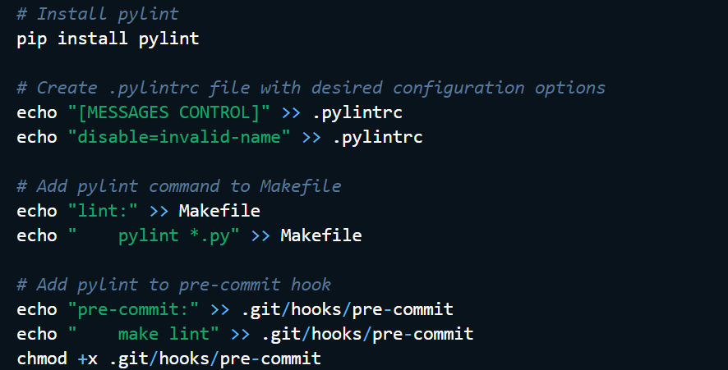

Similar steps can be followed for adding linters to JavaScript, HTML, and CSS projects.

## **General UI Improvements**

**Redirect on Successful License Submission**

Once a new license is submitted via the tool, a green banner shows up saying “success” but it’s a bit fleeting. One has to manually navigate to the GitHub repo to see the issue. Perhaps opening the GitHub issue automatically in a new tab or presenting a link to it would encourage more engagement in GitHub.

To implement this, we can modify the code to include a link to the GitHub repo in the "success" message. This link should direct users to the specific issue that was just created. We can also update the wording of the "success" message to something more explicit about the review process. For example, "Your license request has been submitted for review. Please follow the review process on GitHub at github.com/spdx/spdx-online-tools/issues/id." We can also add an option for users to opt-in to receiving email notifications about the status of their license request. This will help keep them engaged in the review process and encourage participation on GitHub. I have already created a PR for the opening of a new tab on successful license submission, the implementation for the same is given below.

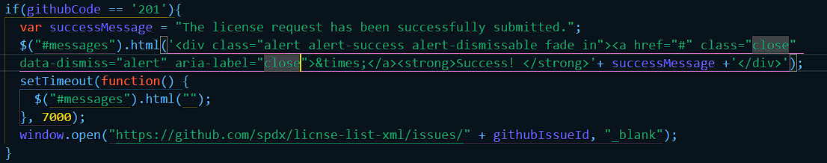

Similarly, for modifying the toast messages, we can implement it by just modifying the text in the `**successMessage**` in `**submit_new_license.html**`.

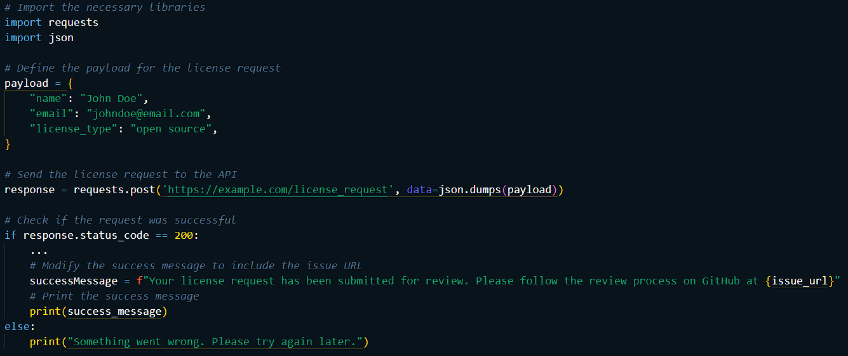

### **Improving the Toast Messages**

Django's built-in `messages` framework is a simple way to display feedback messages to users. However, there are some ways to improve the user experience and make the messages more informative and visually appealing.

We can make use Bootstrap or another CSS framework to style the messages. The default message styles in Django are very plain, so using a framework like Bootstrap can make the messages look more visually appealing and help them stand out on the page. Another thing we can improve upon is use different message levels appropriately. The `**messages**` framework supports several different message levels, including `**DEBUG**`, `**INFO**`, `**SUCCESS**`, `**WARNING**`, and `**ERROR**`. Using these levels appropriately can help users quickly understand the significance of the message.

Instead of just displaying a generic success or error message, we can try to include more specific details about what happened and what the user needs to do next. In the error itself we can add links to related pages which might help in solving the problem. If the message is related to a specific page or action, consider including a link to that page in the message. This can help users quickly navigate to the relevant page and take any necessary action. We can also customize the message tags. We can make use of JavaScript animations we can make the messages more engaging and help them stand out on the page.

Example code for the different type of error messages in jinja template in Django, we will only need to customize the messages and the type which we will get from our `**views.py**` function, everything else will be handled by our frontend.

### **Improving the License Text Display on GitHub Issue Section**

When someone submits a license for review via the Online Tool, portions of the review form are copied into the GitHub issue thread, but notably the submitted license text is not included. It would be helpful if the license text were also copied into the GitHub issue thread.

The proposed solution is to include the license text in the GitHub issue thread, either as a separate comment or as a link depending on its size. For licenses that are small enough, we can include the text in the initial comment along with the other review form details. For larger licenses, we can provide a link to the text.

To implement this solution, we need to modify the code that generates the GitHub issue thread from the review form data. Here are the steps involved:

1. Retrieve the license text from the database based on the license ID submitted with the review form.
2. Check the length of the license text.
3. If the length is less than a certain threshold (e.g., 1000 characters), include the license text in the initial comment along with the other review form details.
4. If the length is greater than the threshold, generate a link to the license text and include it in the initial comment along with the other review form details.
5. Update the database schema to include the license text as a field in the license table.
6. Update the review form UI to show a preview of the license text before submission, so the user can verify that it is correct.
7. Update the GitHub issue template to include a section for the license text or link.
8. Write unit tests to ensure that the license text is correctly displayed in the GitHub issue thread.

With these changes, the license text will be included in the GitHub issue thread, making it easier for reviewers to access and evaluate the license.

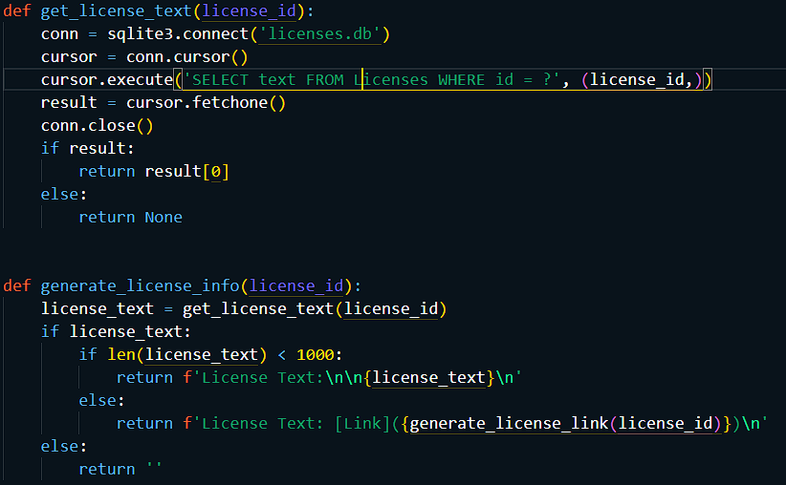

In this example, the `**generate_license_link**` function would generate a link to the license text stored in a separate location, such as a file in a GitHub repository or a URL on a website. These functions could be integrated into the existing code that generates the GitHub issue thread from the review form data to include the license text or link as appropriate.

# **Brief Timeline**

* (Phase 0) Till 27th April: Pre-GSoC Period
* (Phase 1) 4th May – 28th May: Community Bonding Period
* (Phase 2) 29th May – 11th June: Coding Period 1
* (Phase 3) 12th June – 15th June: Phase 1 Evaluations
* (Phase 4) 16th June – 11th July: Coding Period 2
* (Phase 5) 11th July – 14th July: Phase 2 Evaluations
* (Phase 6) 15th July – 28th August: Coding Period 3 and Mentor Evaluation Submission
* (Phase 7) 28th August – 4th September: Final Evaluation

# **Detailed Project Timeline**

## **Phase 0 [Pre-GSoC Period]**

* 3 Weeks (28 March - 25 April)

I’ve been spending time understanding the codebase and solving issues concerning major difficulties which currently exist in the repository. During this period, I’ll try to solve more tasks and also focus on solving some of the GSoC qualification tasks. Along with that, I’ll carry on my experiments and demos with various technologies being used to gain a deeper understanding of the same. I will also be attending calls and gatherings in the SPDX community to get a broader input on the project and understanding their viewpoints. Also, will try to focus upon the module ` **General UI Improvements**` and will try to gain consensus among the community for the UI changes so that we will have a well-defined set of changes which we want to achieve.

* 1 Week (25 April – 3 May)

End semester exams begin at my institute, and I will not be contributing actively during this period. Nonetheless, I’ll be actively following the progress and participate in conversations over gitter & spdx mailist.

Reference: [Academic-Calendar](https://www.spit.ac.in/wp-content/uploads/2022/12/Academic-Calendar-2022-23-Second-Term.pdf)

## **Phase 1 [Community Bonding Period]**

* 3 Weeks (4 May - 28 May)

During the community bonding, the main focus will be to frame a roadmap for the project with the guidance of the mentor (along with improving bonding, which is what the period is for). Additionally, for connecting with the larger SPDX-legal community, I will also be attending calls and gatherings to get a broader input on the project and understanding their viewpoints on the various aspects of the project. This period will also be used to study the already present work on SPDX Online Tool and to figure out a concrete plan to integrate that into the planned ideas. The integration of various parts of the project into one another will be framed, and a source code directory layout will be prepared to keep the flow smooth in later stages of the development. Also, during this period most of the work for the ` **General UI Improvements**` would be completed as they are minimal effort tasks and would not require much time to complete.

All the development-related setup will also be done during this period. NOTE: Once into the coding period I will be following the order; the `**base reusable app**`, the ` **Differentiate exceptions from license submissions**` and the ` **Generate the .txt test file in the pull request (PR) along with the XML file**`, in the development process. Though the modules are independent, it’ll be useful to follow the order above since, while creating the base Django app we can figure out how to divide and enhance the tests and then based on the divisions we can start working on each test module. After completion of these tasks, at the end we can add the linters to the project.

## **Phase 2 [Coding Period 1]**

* 2 Weeks (29 May - 11 June)

I’ll be starting with merging of codes bases from both the API module as well as Django app to create a base app module. Since currently both of these modules are standalone, we will need to see which parts are there in common and based on which the common parts will be extracted into a base app (more details will be shared after in-depth study of both the involved works).

* 1 Week (4 June - 11 June)

During this week, I’ll be writing and modifying the current tests for Django base app. These tests will also be employed in continuous integration. This period will also be used as a buffer to complete documentation and fix bugs in the program.

## **Phase 3 [GSoC Phase 1 Evaluations]**

This period will be used to write a detailed report on the work done in Coding Period 1. All the work done will be uploaded and documentation will be created/uploaded to SPDX-Online-Tool’ wiki.

### **Deliverables**

* Converting the current Django app into a reusable base app, which can be used by any other module which might be implemented in the future.
* Full documentation regarding usage and code.
* Tests for the base Django module.

## **Phase 4 [Coding Period 2]**

* 3 Weeks (16 June - 4 July)

Work on `**Differentiate Exceptions from License Submission**` module will begin; the main task during this period will be the collaboration between all the tools being used and the implementation of parsing the new field which will be added in the xml to avoid a collision. The linkage between the current online app and the new features which will be added simultaneously will be an integral part of the work.

* 1 Week (4 July - 11 July)

Writing tests, documentation, and other work, same as the last week of the coding period 2. Here, the tests will also be written for the combined functioning of the two modules completed until this phase.

## **Phase 5 [Phase 2 Evaluations]**

A detailed report on the working of the processing module and both the modules together.

### **Deliverables**

* Complete the integration of `**Differentiate Exceptions from License Submission**` module into the SPDX-Online-Tools
* Full documentation of the processing module and combined working of both the modules finished till now.
* Tests for both modules, individually as well as functioning together.

## **Phase 6 [Coding Period 3]**

* 4 Weeks (15 July - 21 August)

Work on ` **Generate the .txt test file in the pull request (PR) along with the XML file**`, which will require the format of the XML file to be finalized based on which we would be generating our .txt file. This will also require substantial testing of whether or not the txt file which is being generated contains all the xml attributes functionalities and creation of tests for the same will start in this period only. The integration of different linters into SPDX-Online-Tools will be done during the last week of this period. The work to be done would require the consensus of the community on which linter should be used and will be decided during GSoC period.

* 1 Week (21 August - 28 August)

I’ll work on docker deployment, the creation of tests and writing the final documentation for the module as well as the entire project. As with the last week of every coding period, bug fixes and other minor changes will also be done along with the creation of Developer’s documentation to help integrate other cloud services. This time will also be utilized to finish any pending work in the project, complete all documentation, write Wikis (if needed) and submit mentor evaluation.

## **Phase 7 [Final Evaluation]**

All documentation, modules, and tests will be uploaded, and CI will be integrated into the project GitHub page. **All the deliverables promised for GSoC will be provided by this stage**.

# **Additional Information Regarding Timeline**

* The above timeline is tentative and gives a rough idea of my planned project work. I’ll try to keep progress at, at the very least, the proposed schedule. A more detailed schedule (after gaining in-depth understanding of technologies used) will be planned during the pre-GSoC and community bonding period and shared with the mentor.
* I’ve no other commitments during summer and hence, will be able to dedicate 49 hours to 56 hours a week.
* Each week, time will be divided (according to workload) amongst planning, learning, coding, documenting, and testing features. Except for the developer’s guide, all documentation will go hand in hand with the development. This will help to keep a profound grasp over the code implementation and working, minimizing bugs in the later stages.
* Weekends will be mostly dedicated to testing, bug fixing, and blog writing. Fortnightly blogs will be maintained at <https://medium.com/@vedantjolly2001>and will include highlights of the development process and also methods used to overcome hurdles.
* One of the reasons I’ve been active in SPDX-Online-Tools is due to the immensely helpful community and I’ll try to keep myself continuously updated with other developments going on. I’ll be available for communication at all times decided by my mentor and discuss new ideas and methods throughout the project.
* I’m very enthusiastic about working on SDPX-Online-Tools main code as well and will be taking up issues (outside my GSoC project) as and when time permits.

# **Tentative Spare Tasks**

The above timeline has been made with keeping in mind the maximum time any task could take and the worst-case scenario of having a lot of bugs. Most probably, the work will be done before the end of the GSoC period and hence I would love to work on the below-mentioned tasks. I would be working on first and the last irrespective of GSoC selection.

* **Overhaul SPDX-Online-Tool’s Documentation**

With the help of my mentor, I would like to revamp SPDX-Online-Tool’s wiki and documentation and follow standardized guidelines to create documentation for developers as well as users. Documentation is a crucial component of any project which helps newcomers start contributing quickly and I feel we need improvement in that aspect (though an active and helpful community compensates for it at gitter).

* **Automatically archive or remove the license listing from the online tool UI, once the PR is merged**

Once a PR is merged, the GitHub webhook will trigger the API endpoint, which will extract the relevant information from the merged PR, including the license file name, SPDX identifier, and other metadata. The endpoint will then use this information to call the SPDX database API to update the license listing status to "**archived**".

After updating the license listing status, the endpoint will remove the archived license listing from the online tool UI. This can be done by deleting the relevant HTML page or updating the UI to remove the listing. The specific method of removal will depend on the structure of the online tool UI.

* **Resolve SPDX-Online-Tools Bugs**

There are a lot of bugs currently in SPDX-Online-Tool’s main module and due to this the development cycle has been slow. I’ll try to solve as many bugs as possible during the pre-GSoC period (mentioned in the timeline) and then try to solve more once my project has been completed. This is also a task I look forward to being doing perpetually and being involved in the community.

# **Personal Information**

## **Personal Details**

I’m Vedant Jatin Jolly, an undergraduate student at Sardar Patel Institute of Technology, Mumbai (India). I had been fascinated by programming since I was 17; I have always believed that “coders are the sorcerers of the 21st century”. It conveys that they have the power to create tools for the upliftment of humankind and what better way to do so than open-source contributions. My experience with open source is relatively small but it has been so exciting that I’ve been contributing to multiple projects once I got acquainted with the concept. It has been a steep learning curve for me. Open-source contributions have made me realize the importance of documented and easy to understand the code. I have a firm knowledge of C, Java, Python and industrial acquaintance with web-development technologies such as HTML, CSS, JavaScript and Django as I have previously completed various internships in the software domain field to enhance my knowledge base. I’m awestruck by the way Python has overtaken almost all other languages in every development sector due to its simplicity and lesser development time. Python gives the developers the freedom to spend more time on innovation and less time on actual implementation, which is a major distinguisher from languages like C.

I use Ubuntu 20.04 along with PyCharm (exclusively for Python) and Visual Studio Code (for every other language) as my default editors due to the large repository of extensions they feature. For testing purposes, I have been using a Digital Ocean droplet which allows me to deploy changes to an independent environment and then analyze the effects.

## **Projects and Previous Experiences**

I have had previous research experiences with **Tata Institute of Fundamental Research** and **SP Jain Institute of Management and Research**.

Currently working in the Department of Astronomy & Astrophysics under the Seismology group under the guidance of SHRAVAN HANASOGE. Working upon modelling and training machines on solar observations to predict magnetic processes such as flares and field emergence. We apply a variety of tests on such machines to try to extract the patterns they have learnt. Also working on Large seismic datasets that are being extracted from high-resolution observations of the Sun – typically resulting in high-dimensional inverse problems. Appropriately conditioning and parameterizing the inverse problem so as to accurately recover internal structure is another topic on which I am currently working upon. I have developed a machine learning algorithm that identifies red giants from the raw oscillation spectra and captures p and mixed mode parameters from the red-giant power spectra. To validate the results of this method, we selected ∼ 3,000 Kepler stars, at various evolutionary stages ranging from subgiants to red clumps, and compare inferences of ∆ν, ∆Π, and νmax with estimates obtained using other techniques.

During my research internship at the Tata Institute of Fundamental Research, I worked on developing machine learning models for image classification and object detection. I also developed a web application using Django to deploy these models for image recognition. This project involved dealing with large datasets, data preprocessing, model training, and integration with a web application.

Similarly, during my time at SP Jain Institute of Management, I worked on building a social media sentiment analysis tool that collected tweets from Twitter and analyzed them using machine learning algorithms. This project also involved web scraping, data cleaning, and model training using Python.

Both of these projects required a strong understanding of Python and its libraries for machine learning and web development. They also involved dealing with data in various formats, such as CSV, JSON, and XML.

In the SPDX Online Tools project, automating the process of archiving or removing the license listing from the UI after merging a pull request can involve dealing with large datasets of license information and updating the corresponding XML files, which also involves developing a web application using Django for handling these changes.

With my extensive experience in Python and web development using Django, I have acquired the proficiency to build scalable and robust web applications. This makes me an excellent candidate for the SPDX GSoC program. My past projects showcase my ability to develop feature-rich applications with clean and maintainable code, which is crucial for the success of any project. Additionally, my expertise in database design and management, as well as knowledge of front-end technologies like HTML, CSS, and JavaScript, make me a well-rounded developer capable of handling all aspects of web development.

However, what sets me apart from other applicants is not only my technical skills but also my project management skills. I possess excellent communication and interpersonal skills, enabling me to work collaboratively with other team members and stakeholders effectively. I have experience in creating project timelines, identifying potential roadblocks, and developing mitigation strategies to ensure projects are completed on time and within budget. Furthermore, my ability to prioritize tasks, delegate responsibilities, and maintain an organized workflow has resulted in the successful completion of complex projects in the past.

## **Working Environment and Schedule**

I’ll be mostly working full-time on the code on weekdays (Monday to Friday). On weekends, I’ll be focusing on documentation, testing and bug fixing. My awake hours would usually be in between 10 AM IST (4:30 AM UTC) to 2 AM IST the next day (8:30 PM UTC) and I’m comfortable working anytime during this period. Except for a few days of traveling (which I’ll be informing in advance to my mentor), I’ll be having no other absences. Anyhow, in cases of emergency, I’ll responsibly notify my mentor of the same with enough detailing.

I’ll be working from home where I’ve constant and unlimited high-speed internet so working and connecting with the mentors constantly won’t be a problem.

## **Communication**

I’m very flexible with my schedule and already have the habit of working at night and hence timezone variation (with my mentor) won’t be an issue. I’m comfortable with any form of communication that suits my mentor. Below are the various options available:

* Email: vedantjolly2001@gmail.com
* Phone (Call, WhatsApp): (+91) 9004012177
* Hangouts: vedantjolly2001@gmail.com
* Slack: vedantjolly2001
* GSoC blogs: medium.com/@vedantjolly2001

# **Contributions**

## **Issues Opened & Contributed To**

*Arrangement: Top is oldest*

* [Clean up isDeprecated values](https://github.com/spdx/license-list-XML/issues/1545)
* [Add clean up disk space feature](https://github.com/spdx/spdx-online-tools/issues/328)
* [Error when submitting a license](https://github.com/spdx/spdx-online-tools/issues/308)
* [Update Contributing.md](https://github.com/spdx/spdx-online-tools/issues/446)
* [Redirect on Successful License Submission](https://github.com/spdx/spdx-online-tools/issues/449)
* [license request page updates](https://github.com/spdx/spdx-online-tools/issues/452)
* [Design Issue on Submit License Page](https://github.com/spdx/spdx-online-tools/issues/455)
* [[Python3] Option to check license diff on submit license page before submitting](https://github.com/spdx/spdx-online-tools/issues/346)

## **Pull Requests Created & Merged**

*Arrangement: Top is Oldest*

* [Remove the `isDeprecated` field from the license](https://github.com/spdx/license-list-XML/pull/1862)
* [Error When Submitting License](https://github.com/spdx/spdx-online-tools/pull/443)
* [Add clean up disk space feature](https://github.com/spdx/spdx-online-tools/pull/440)
* [Update Contributing.md](https://github.com/spdx/spdx-online-tools/pull/448)
* [Fixing Redirect on Successful License Submission](https://github.com/spdx/spdx-online-tools/pull/450)
* [Spelling Mistake](https://github.com/spdx/GSoC/pull/11)
* [Intended to Solve the design issue on the Submit License Page](https://github.com/spdx/spdx-online-tools/pull/459)
* [Added button to check license diff on Submit new License Page](https://github.com/spdx/spdx-online-tools/pull/461)

I am confident that my contributions to the SPDX community have prepared me well for the SPDX GSoC program. I have demonstrated my ability to work independently and collaboratively to fix bugs, update documentation, and add essential features to the tool.

One of my most significant contributions to the project was the implementation of the "**Clean up disk space**" feature. This update involved developing a script that could automatically delete files and folders that were no longer needed, freeing up valuable disk space. This feature was critical for ensuring that the tool's performance remained optimal. Another major feature which I worked upon, was the addition of a button on the “**Submit New License**” page which allows the user to check if the **license text matches** with some previously existing license in the database. This feature makes the application more user friendly as previously, the user had to change tabs and check whether the license existed or not, thus this update helped the application become more user friendly as well as efficient.

In addition to my technical contributions, I have also actively engaged with the SPDX community through communication via mailing lists, IRC, and Gitter. This has allowed me to stay up-to-date with the latest developments in the project and work collaboratively with other contributors to address issues and improve the tool. Through these channels, I have not only learned about the project but also contributed to it by fixing bugs, reporting issues, and providing feedback on pull requests. I have made it a priority to remain engaged with the community and help other members when needed.

Moreover, I have also worked on other issues such as cleaning up `**isDeprecated values**`, `**redirecting on Successful License Submission**`, `**error when submitting a license**`, and `**updating the Contributing.md file**`. These tasks required careful attention to detail and a thorough understanding of the codebase, and I am proud to have contributed to the project's success.

Overall, my experience in contributing to the SPDX-Online-Tools project has given me a deep understanding of the tool's functionality and the needs of its users. I am confident that my technical skills, project management skills, and commitment to the community make me an ideal candidate for the GSoC program. I believe that I can make significant contributions to the project's development and would be honored to be selected for the program.

# **Post GSoC Plans**

I’m not applying for GSoC under any other organization this year since I am motivated by the journey SPDX-Online-Tools has been through and I want to be an integral part of it. I’ve already mentioned spare GSoC tasks and will be implementing them post GSoC (if not able to complete during the GSoC period). I’ll also be looking forward to contributing to the integration of `Generate the SPDX specification text` in SPDX-Online-Tools. It was another project that fascinated me at the ideas page. The SPDX v3 specification is being developed via a set of consistently structured Markdown files in a special repository. These files are automatically processed by a tool in order to generate markdown files to be published in GitHub pages. The goal of the project is to extend the current tool to handle the latest version of the model files and generate the specification in a format similar to the current SPDX v2 text. Therefore, having support for it will help SPDX-Online-Tools become more useful and robust to the users.

I would love to work on its integration (in my spare college time) if the project is not done this time in Google Summer of Code. In case the project is completed this time, I’ll try to provide patches and bug fixes for it since I want to contribute to the project in some or the other way. Along with that, I’ll always be a part of SPDX-Online-Tools and will be following (as well as contributing towards) its development. I will always be available to make changes to the project and expand its feature set as and when need be.

## **References**

In the research and making of this proposal, multiple sources have been used and they have been hyperlinked at the place of their usage for ease of reading and verification. All the diagrams were made with the help of draw.io’s interactive editor. I believe in Python’s way, “seek forgiveness not permission” and therefore, at some places self-deductions and experiments have been used to put results into the limelight. The experimental observations could vary between system setups and also give a different result (though very unlikely).